Cloud-Native Sample Application Architecture

Table of Contents
Sample Application Architecture 2
System Overview 2
Deployment Architecture 3
Data Flow 4
Security Architecture 5
Observability Stack 6
Development Workflow 6

Sample Application Architecture
Reference architecture for a cloud-native e-commerce platform demonstrating the standards in practice.

System Overview
A full-stack e-commerce demonstration featuring microservices (Java 21/Spring Boot) and React frontend with Google OAuth and local authentication. Supports deployment on both local Kind clusters and GCP Cloud Run.
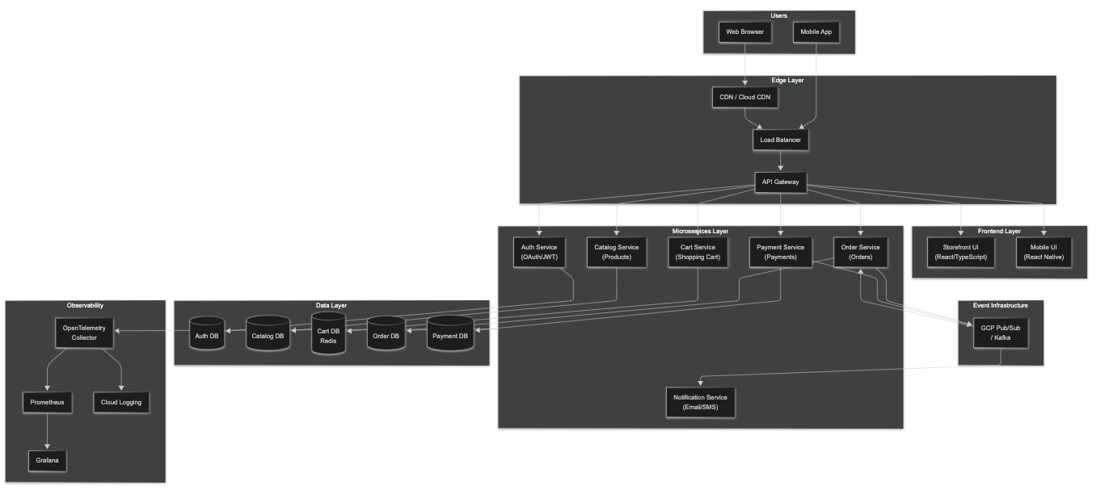

Deployment Architecture

GCP Cloud Run Deployment
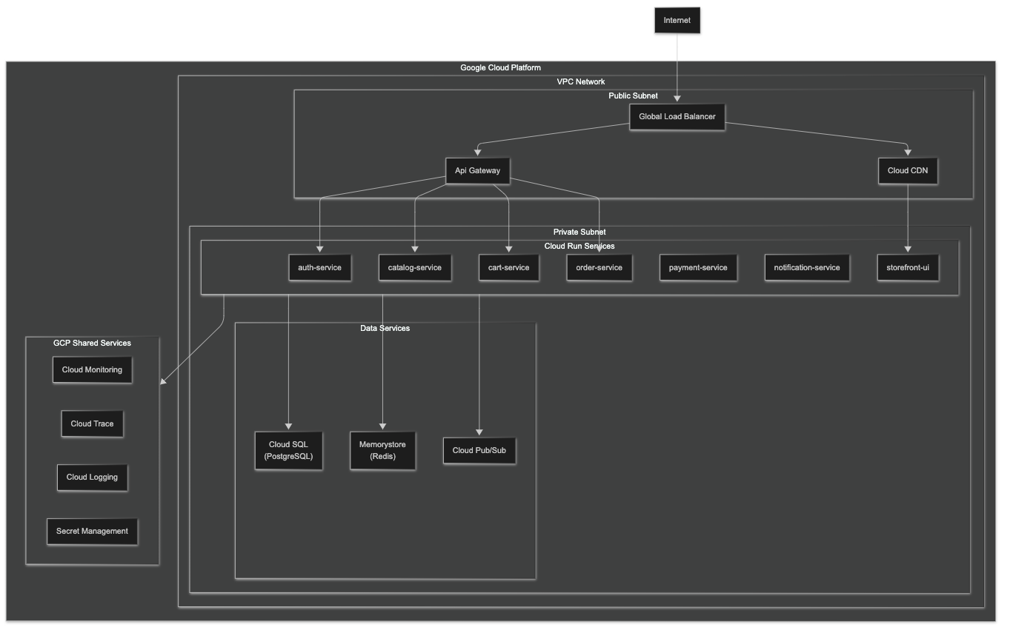

Data Flow

Order Processing Flow
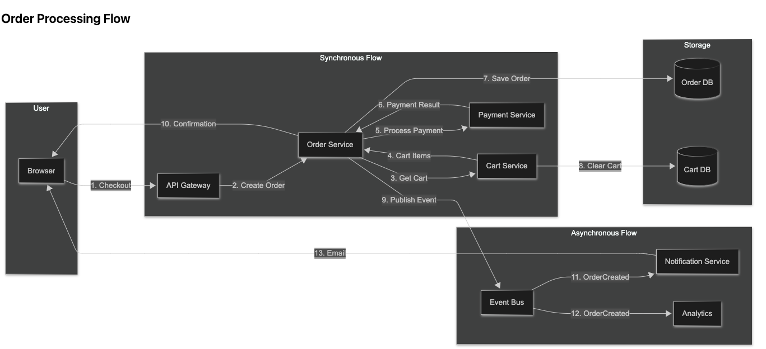

Security Architecture
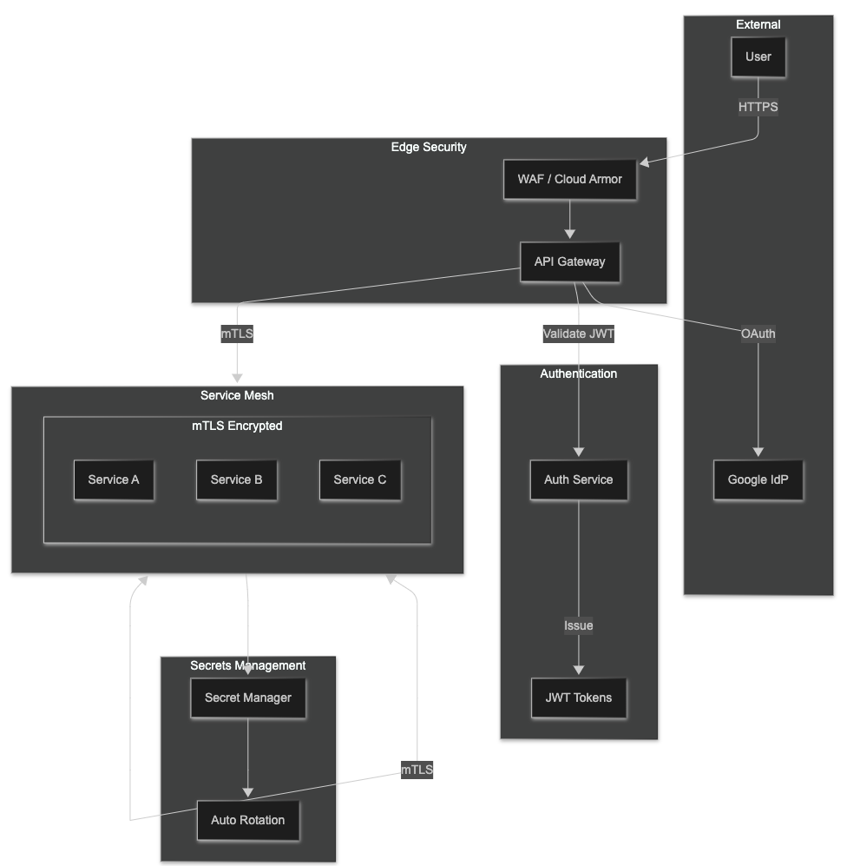

Observability Stack
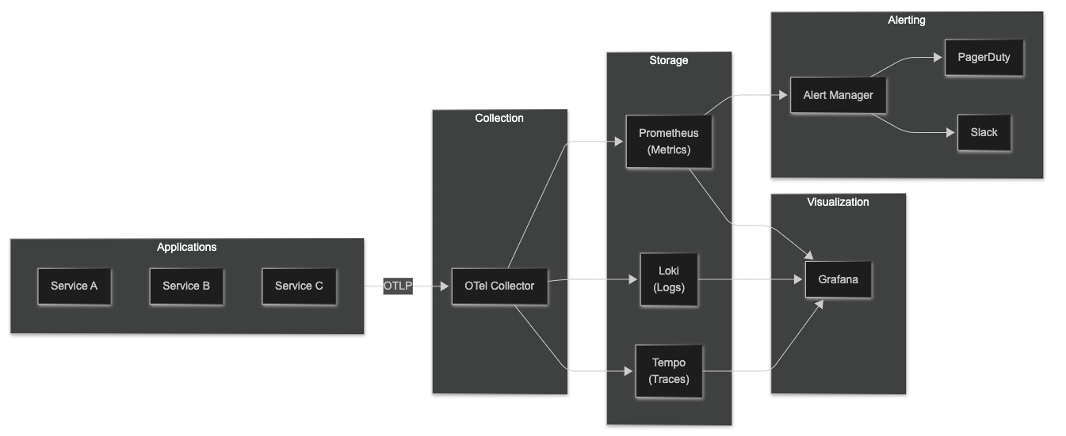

Development Workflow
